General Public: Social Media Posts
This document is to be used as sample social media posts for your Municipal social media platforms.
Regional Municipal Posts:
Photo:
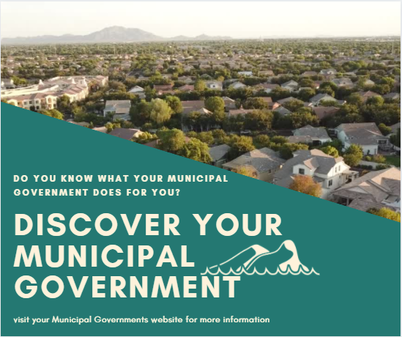
Caption: “Do you know what your Municipal Government does for you?”
What is the difference between your County Government and your Local Municipal Government?
Your Regional Municipal Government provides services such as:
- Arterial Roads
- Health Services Sewer and Water Systems
- Waste Disposal
- County land use Planning and Development
- Social Services
Your local Municipal Government provides services such as:
- Parks and Recreation
- Libraries
- Community Water Systems
- Local Police
- Roadways and Parking
The Regional Municipal Government and Local Municipal Government work collaboratively to provide you with a sustainable, innovative, and a prosperous, growing community.
#County #Local #Municipality #Community

Photo:
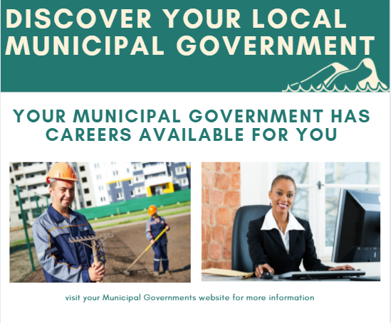

Caption: Your Municipal Government has careers available for you!
Municipal Government departments offer careers to a wide range of individuals with training in various programs of study, and work experience.
Your Municipal Government has several different departments from, health services, communications, economic development, transportation, waste management, long-term care, corporate services, and information technology.
Visit your Municipal Government website for more information on careers.

Local Municipal Government Posts:
Photo:
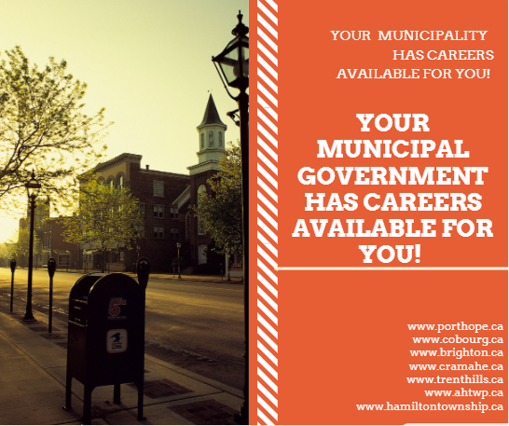
Caption: Why should you consider a career in Local Municipal Government?
Your Local Municipal Government offers great opportunities for experienced workers or new graduates. Enjoy a job that provides you with
- Opportunities for Financial Security and Career Advancements
- Benefits
- Mentoring
- On-going Training

Start your career with your Local Municipal Government, and make a difference in your local community!
Visit your Local Municipal Government website for more information and to learn about new job postings.
#Career #WorkLocal #Municipality #MunicipalGovernment

Photo:
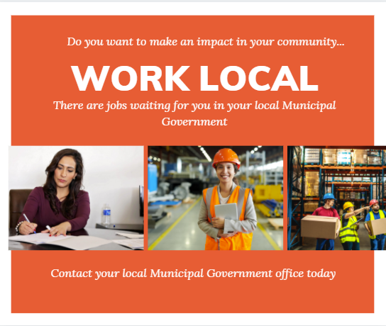
Caption: Your Local Municipal Government offers careers in a variety of sectors. Municipal governments have several different departments that help sustain and maintain your beautiful community.
Departments may include,
- Community Development
- Corporate Services
- Finance
- Fire and Emergency Services
- Municipal Project Staff (MPS)
- Parks, Recreation and Culture
- Works and Engineering
For more information on your Local Municipal Governments visit their website,
www.porthope.ca
www.cobourg.ca
www.brighton.ca
www.cramahe.ca
www.trenthills.ca
www.ahtwp.ca
www.hamiltontownship.ca

