Succession Planning Approach: Things to Consider

- Sample flow chart identifying the steps in the succession planning process.

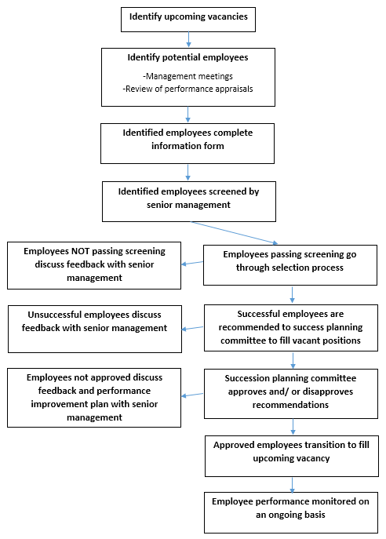

- A sample form that can be used to collect information from employees in order to determine their suitability to fill the organization’s upcoming vacancies.

Employee Information
Name:
Title:
Job Classification:
Length of Service:
Time in Current Job:
Current Supervisor:
Career Goals
1 to 3 Years:
3 to 5 Years:
Beyond 5 Years:
Educational History
Institution: | Degree: |  | Area of Study: | Years:
Institution: | Degree: |  | Area of Study: | Years:
Institution: | Degree: |  | Area of Study: | Years:
Special Skills/Expertise
Languages:
Technology:
Professional Expertise:
Other:
Developmental Experiences - Past 3 Years
Formal Training: |  | Competencies/Skills Developed:
Special Assignments: |  | Competencies/Skills Developed:
Other: |  | Competencies/Skills Developed:

Adapted from Byham, William C., Audrey B. Smith, Matthew J. Paese. 2002. Grow Your Own Leaders. Acceleration Pools: A New Method of Succession Management. Upper Saddle River, NJ: Prentice-Hall Inc.

- Determine how the identified employees will be evaluated to determine those that are best suited to fill the vacancies.

Tactic: A combination of selection activities that could include an interview and/or an in-basket exercise.

- How will the most qualified employees be transitioned into the respective vacancies.

Tactic: Identified employees could job shadow the current incumbents until their retirement. Job shadowing could be on a part-time or a full-time basis.

- How will the lesser qualified employees be dealt with by the organization.

Tactic: Senior management could prepare these employees to fill future internal vacancies by discussing areas of improvement that they need to work on and develop a performance improvement plan to help monitor their progress.

- What follow up activities will the organization undergo to monitor the progress of all identified employees.

Tactic: All employees will receive performance evaluations on either an annual or semi-annual basis.

